# קבצי קלט ופלט התוכנית:

הספרייה ללא התמונות המפוענחות:

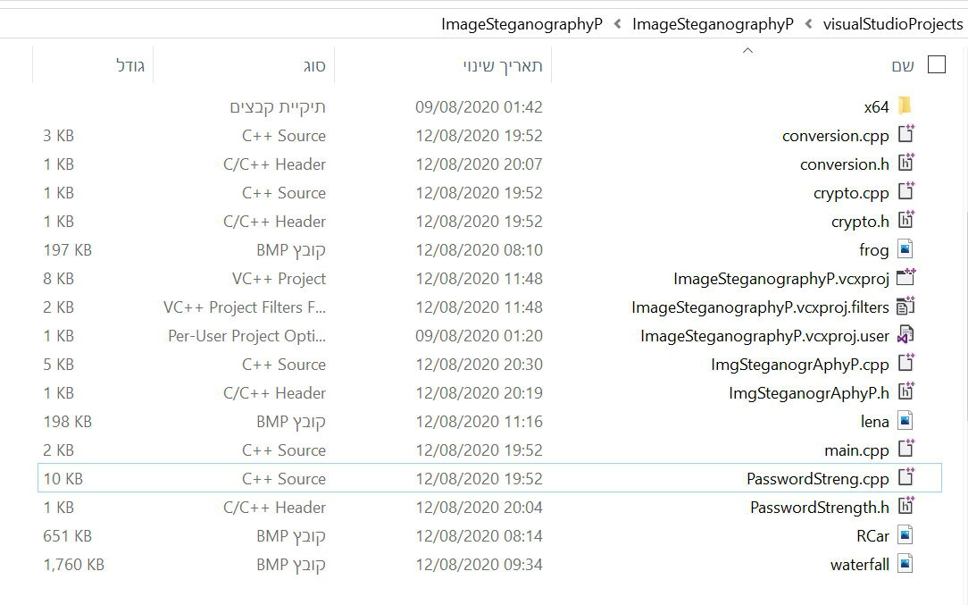

הרצה 1:

Menu options:

0 -- exit the program

1 -- Checking password strength and entering a password to encryption

2 -- Password Encryption for Image

3 -- To decode a password from an encrypted image

Please choose a menu option: 1

Press '0' if you want an explanation of the password strength

Otherwise press any button to enter the password:

0

Password length must be at least 8 characters (up to 12 characters).

- The password can be uppercase(A - Z)

- The password can be lowercase(a - z)

- Password can contain digits(0 - 9)

- The password can contain symbols(such as!, @ ...)

A user cannot enter a password less than a score of 70.

weak: 70 - 80

moderate : 80 - 90

Strong : 90 - 100

Please enter your password

msh12457!

Press '0' if you want to know what the score was about and what the password strength score is

Otherwise press any button

0

The strength of your password Before the Subtraction of the score is 94

subtracting:-4 subtracting points- The amount of lowercase letters

subtracting:0 subtracting points- The amount of capital letters

subtracting:-8 subtracting points- The amount of digits

subtracting:0 subtracting points- sequence of digit in ascending or descending order

subtracting:0 subtracting points- sequence of letters in ascending or descending order

The strength of your password is: 82

the srtong of password: - Moderate

Do you want to improve the password strength score Press 0

otherwise click any button

0

Press '0' if you want an explanation of the password strength

Otherwise press any button to enter the password:

f

Please enter your password

Msh12457!

Press '0' if you want to know what the score was about and what the password strength score is

Otherwise press any button

f

The strength of your password is: 100

the srtong of password: - Strong

Menu options:

0 -- exit the program

1 -- Checking password strength and entering a password to encryption

2 -- Password Encryption for Image

3 -- To decode a password from an encrypted image

Please choose a menu option: 2

Do you want to use the images in the database prass '0' .

To insert a new image prass '1'

For default image Click any button :

0

To image of car Tap '0'

To image of Waterfall Tap '1'

To image of frog Tap '2'

0

Encrypted: 3.TzuqD

Menu options:

0 -- exit the program

1 -- Checking password strength and entering a password to encryption

2 -- Password Encryption for Image

3 -- To decode a password from an encrypted image

Please choose a menu option: 3

after the seganographly

Msh12457!

Menu options:

0 -- exit the program

1 -- Checking password strength and entering a password to encryption

2 -- Password Encryption for Image

3 -- To decode a password from an encrypted image

Please choose a menu option: 0

thex for using the program

C:\Users\Moshe\visualStudioProjects\ImageSteganographyP\x64\Debug\ImageSteganographyP.exe (process 18600) exited with code 3.

To automatically close the console when debugging stops, enable Tools->Options->Debugging->Automatically close the console when debugging stops.

Press any key to close this window . . .

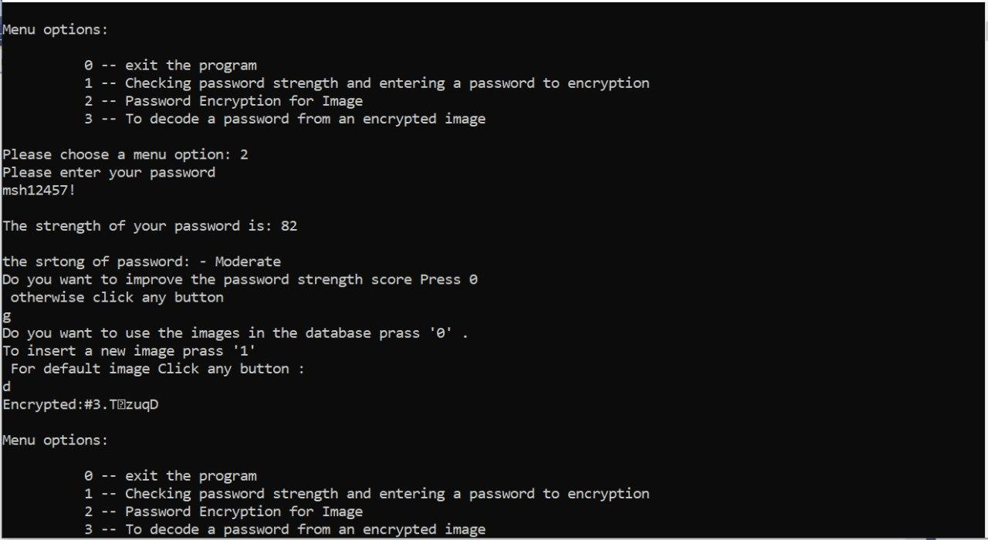

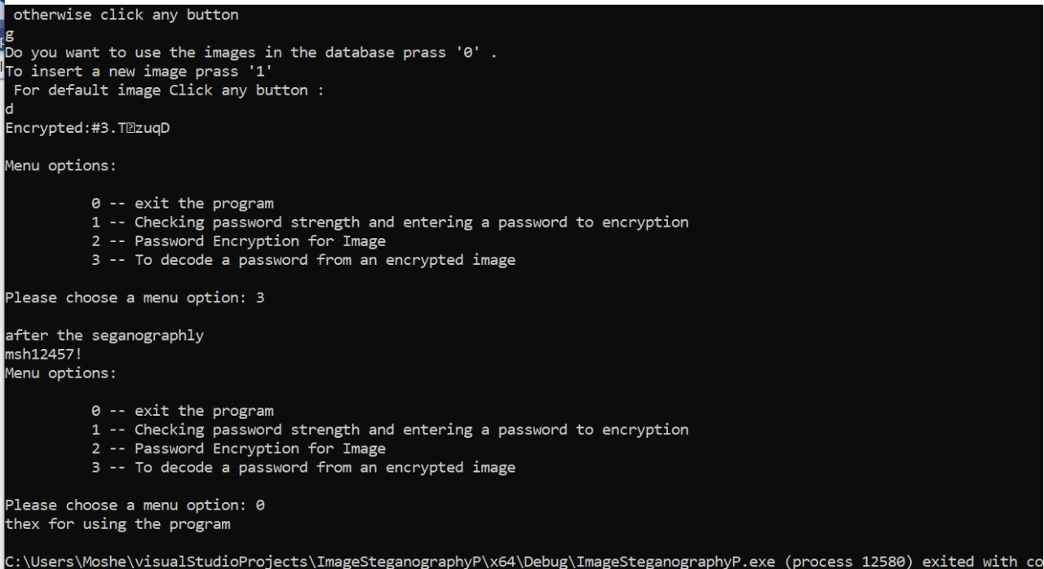

הרצה 2:

Menu options:

0 -- exit the program

1 -- Checking password strength and entering a password to encryption

2 -- Password Encryption for Image

3 -- To decode a password from an encrypted image

Please choose a menu option: 2

Please enter your password

msh1245

Your password is shorter than 8 characters.

Please enter a password between 8 and 12 characters

msh12457

The strength of your password is: 66

the srtong of password: - Your password is too weak. Please enter a new password

Please enter your password

msH12457!

The strength of your password is: 100

the srtong of password: - Strong

Do you want to use the images in the database prass '0' .

To insert a new image prass '1'

For default image Click any button :

0

To image of car Tap '0'

To image of Waterfall Tap '1'

To image of frog Tap '2'

0

Encrypted:#3

TzuqD

Menu options:

0 -- exit the program

1 -- Checking password strength and entering a password to encryption

2 -- Password Encryption for Image

3 -- To decode a password from an encrypted image

Please choose a menu option: 3

after the seganographly

msH12457!

Menu options:

0 -- exit the program

1 -- Checking password strength and entering a password to encryption

2 -- Password Encryption for Image

3 -- To decode a password from an encrypted image

Please choose a menu option: 0

thex for using the program

C:\Users\Moshe\visualStudioProjects\ImageSteganographyP\x64\Debug\ImageSteganographyP.exe (process 15312) exited with code 3.

To automatically close the console when debugging stops, enable Tools->Options->Debugging->Automatically close the console when debugging stops.

Press any key to close this window . . .

התמונות – לפי ואחרי הצפנה

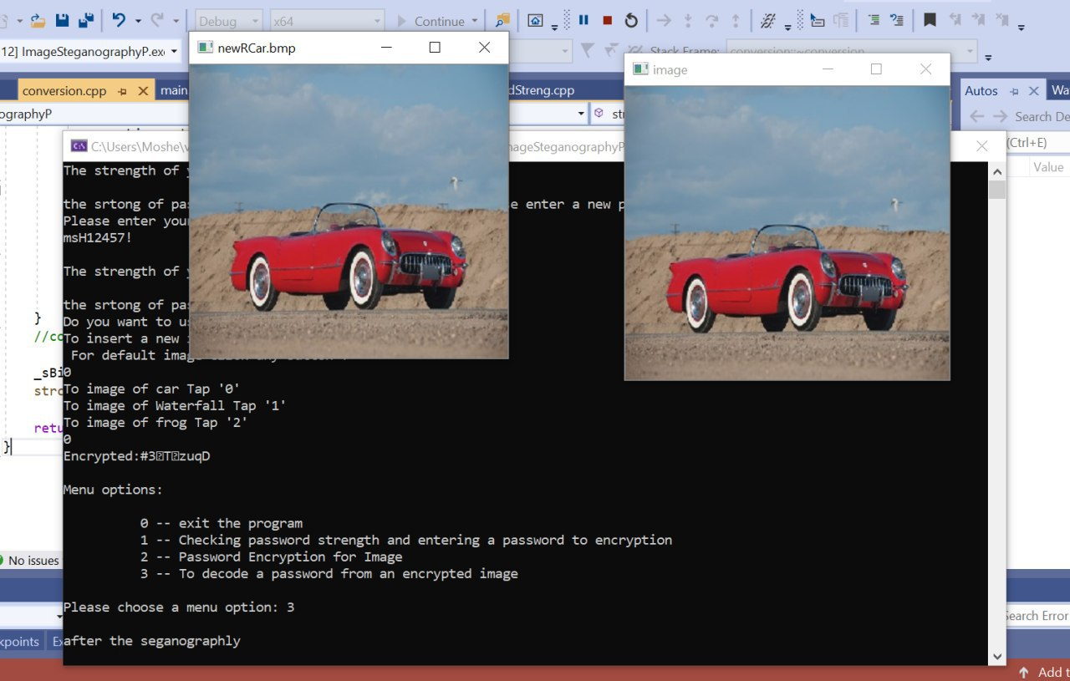

הרצה 3:

Menu options:

0 -- exit the program

1 -- Checking password strength and entering a password to encryption

2 -- Password Encryption for Image

3 -- To decode a password from an encrypted image

Please choose a menu option: 2

Please enter your password

mshH12457!

The strength of your password is: 100

the srtong of password: - Strong

Do you want to use the images in the database prass '0' .

To insert a new image prass '1'

For default image Click any button :

0

To image of car Tap '0'

To image of Waterfall Tap '1'

To image of frog Tap '2'

2

Encrypted:#3.-|tsR

Menu options:

0 -- exit the program

1 -- Checking password strength and entering a password to encryption

2 -- Password Encryption for Image

3 -- To decode a password from an encrypted image

Please choose a menu option: 3

after the seganographly

mshH12457!

Menu options:

0 -- exit the program

1 -- Checking password strength and entering a password to encryption

2 -- Password Encryption for Image

3 -- To decode a password from an encrypted image

Please choose a menu option: 0

thex for using the program

C:\Users\Moshe\visualStudioProjects\ImageSteganographyP\x64\Debug\ImageSteganographyP.exe (process 23240) exited with code 3.

To automatically close the console when debugging stops, enable Tools->Options->Debugging->Automatically close the console when debugging stops.

Press any key to close this window . . .

הספרייה עם התמונות המפוענחות:

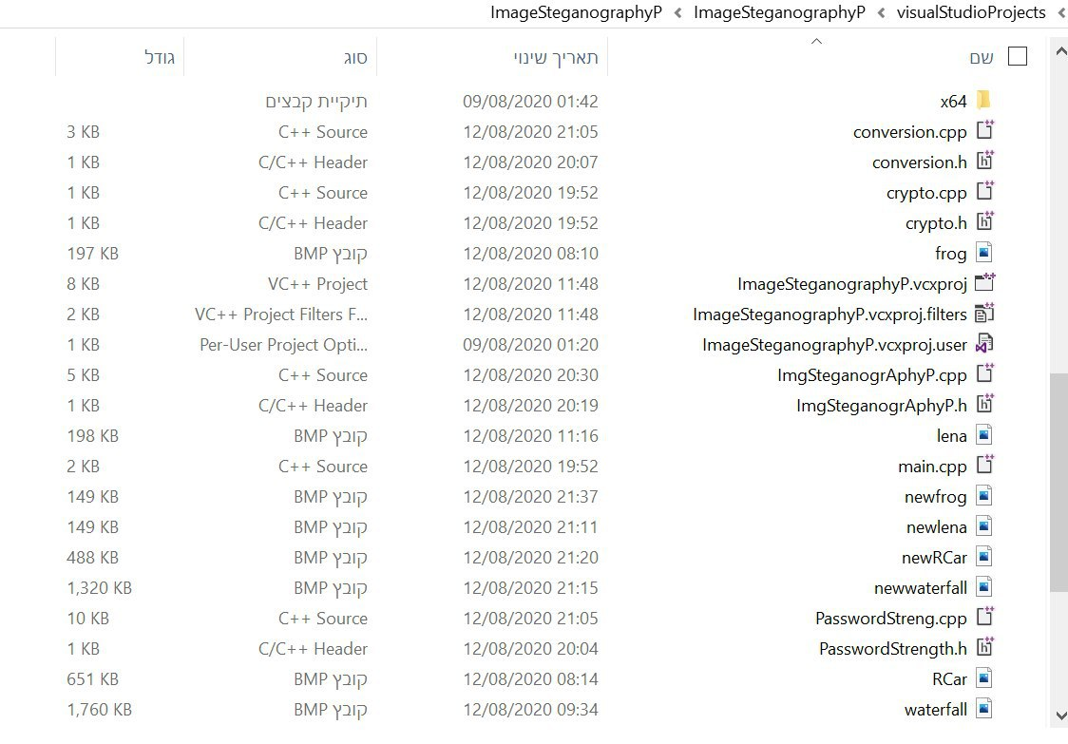

ראה את 3 התמונות המפוענחות לאחר ההרצה